Shammah Thao

5/8/20

CPE 138

Mininet Walkthrough

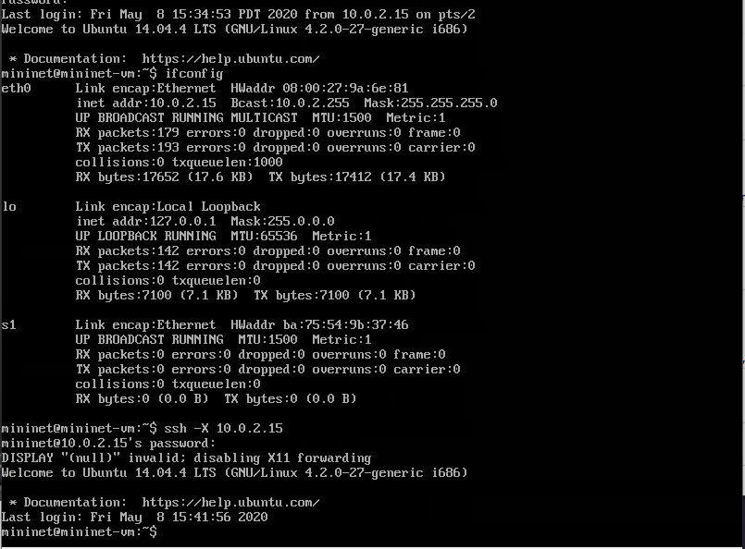

Logged into the virtual box, user and pass both being mininet.

Got my inet address from eth0 using Ifconfig

Ssh into my inet address in the command prompt since using windows

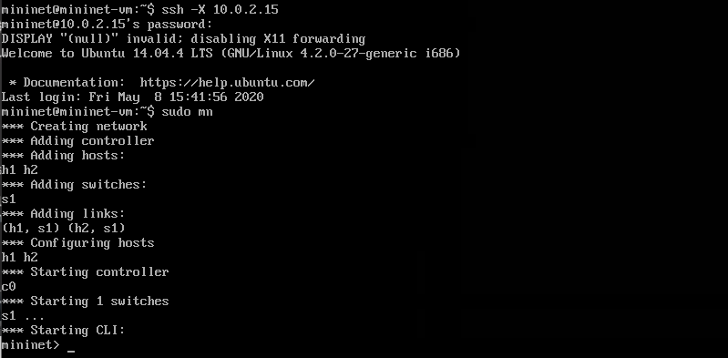

Used sudo mn to create different amount of networks that come with different host and switches

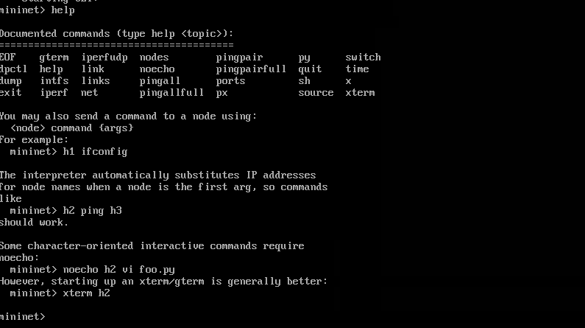

Different kind of thing I could do with “help” command

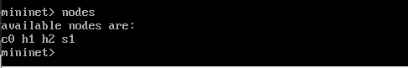

Using “nodes” command, it shows the available nodes

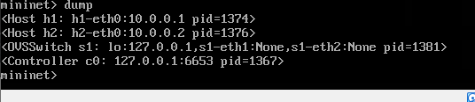

Dump shoes the different host address along with its pid.

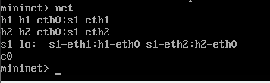

Using net to see what hosts are connected to which ip address

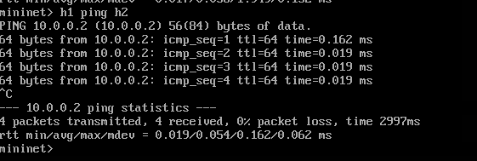

H1 ping to h2, ctrl C to exit, as the first one was done the other are able to ping h1 host faster to h2.

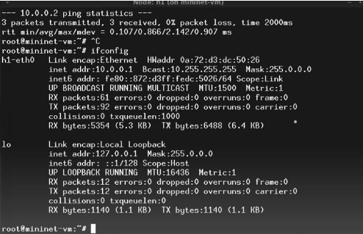

Using xterm h1 we go to the mininet-vm and used ifconfig

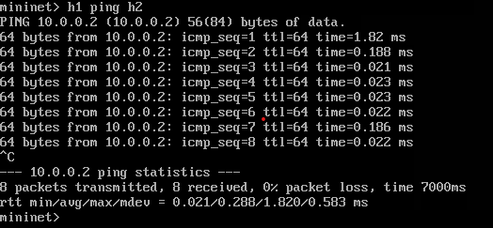

Exited out of the mininet-vm, goes back to virtual box, used h1 ping h2 to see the difference it made

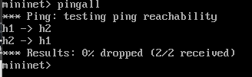

Used pingall, none was losed

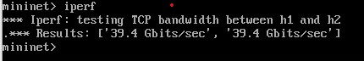

Used iperf to test the tcp bandwidth between h1 and h2

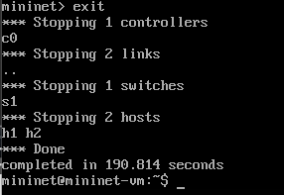

Exited out of mininet

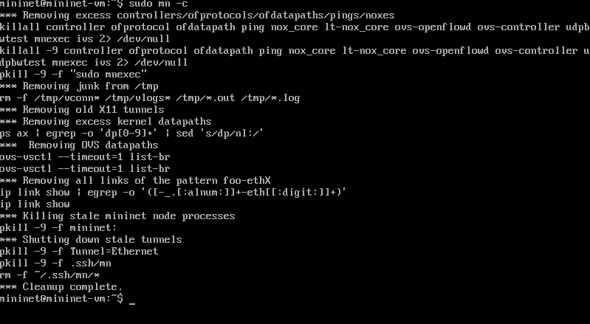

Clean up the cached from sudo mn using sudo mn -c

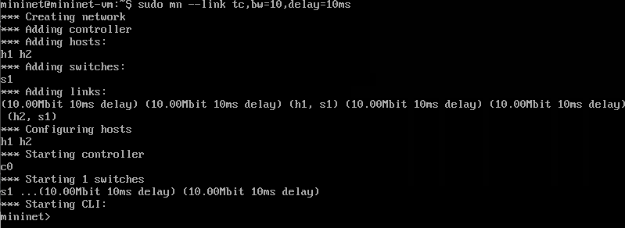

Used sudo mn –link tc,bw=10,delay=10ms creating the same host but this time with delays

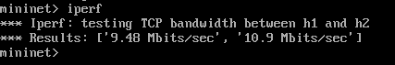

Used iperf again to see the changes

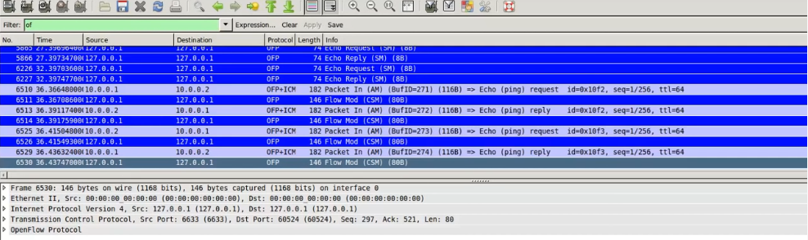

used Wireshark to see the host pinging each other.

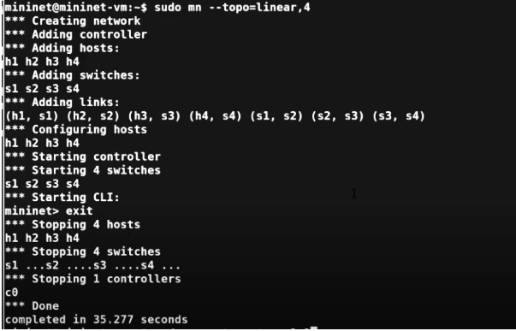

Created different host that are in linear to each other. Created s1 – s4

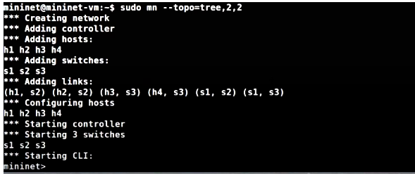

Created a tree using the different nodes or hosts.